Email: patents@cumail.in,

INSTRUCTIONS:
1. Go to File 🡪 Download 🡪 Microsoft Word (.docx)
2. Download the IDF in your local storage
3. Explain your invention comprehensively in the form.
4. Save your IDF file with the name of the Title of your invention. eg: "A Smart Electric Kettle"
5. Upload the duly filled IDF below.

INVENTOR DETAIL:

NAME: MOHD SHAN
GENDER: MALE
EMAIL: THEMOHDSHAN@GMAIL.COM
MOBILE NO:9084296657
DEPARTMENT: BE-CSE
DESIGNATION: STUDENT
SCANNED HAND SIGNATURE: 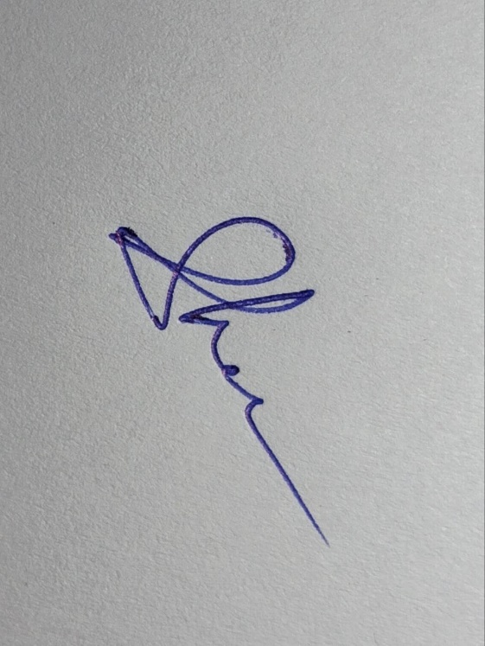

OTHER INVENTOR DETAIL:
NAME:
GENDER:
EMAIL:
MOBILE NO:
DEPARTMENT:
DESIGNATION:
SCANNED HAND SIGNATURE:

A) Please enlist the Key concepts and terms/Keywords/Synonyms used in the Invention?
S. No | Keywords for Invention | Synonyms / Alternate Terms
1 | Automatic Drug Injector | Auto-injector, Self-injection device, Smart injector
2 | Wearable Medical Device | Smartwatch device, Health band, Medical wrist gadget
3 | Emergency Injection System | Life-saving injector, Critical care dispenser, Immediate aid system
4 | Scheduled Drug Delivery | Timed injection, Pre-set dosage system, Automated medicine dispenser
5 | Cardiac Sensor | Heartbeat detector, ECG sensor, BPM monitor
6 | Liquid Medicine Container | Drug vial, Syringe capsule, Cartridge-based injector
7 | IoT-based Health Monitoring | Internet-connected health tracker, Remote sensing medical device

1. TITLE OF INVENTION- 15 words max

AutoMedi-shan

2. BACKGROUND OF THE INVENTION- prior art search, tell what was the problem in past and how your invention overcome it. Compare your invention with closet prior art.

Medical emergencies like heart attacks or asthma attacks require immediate medication. Traditional systems rely on human intervention, which can be delayed or unavailable. Chronic patients also face challenges in keeping track of medication schedules, especially those requiring injections like insulin.
While some auto-injectors and wearable devices exist, none integrate multi-drug liquid storage, real-time heart monitoring, and automatic injection in one wearable device.
Our invention bridges this gap by combining a smartwatch form factor with drug delivery mechanisms. It senses heart rate anomalies (e.g., signs of heart attack) and triggers an emergency injection autonomously. Additionally, it allows scheduling injections and dosage mixing of multiple medications.
Compared to conventional methods, our system offers faster emergency response, hands-free scheduled dosing, and doctor-configurable multi-drug control—all in a single wearable device.

3. OBJECTIVE OF THE INVENTION
• To provide an intelligent, wearable solution for scheduled and emergency drug delivery.
• To enable automatic injection of medications upon detecting abnormal heart rate conditions.
• To support multi-drug storage and mixing in liquid form.
• To offer a safe, compact, and user-friendly experience for chronic or emergency-prone patients.

4.NOVEL ASPECTS OF THE INVENTION (Point out the new parts used in the invention which make it different from the other existing inventions or prior arts).

• Multi-cylinder storage of liquid medications inside a watch-like device.
• Smart injection system integrated into the wrist strap for direct, concealed injection.
• Heart rate sensor triggering automatic emergency injection upon detecting arrhythmias or attack-like symptoms.
• Microcontroller-based scheduling system allowing precise timing and dosage of medicine.
• Dynamic drug mixing valve system—capable of injecting two mixed drugs or one at a time.
• Display interface showing real-time heart rate, medicine levels, and battery status.
• Top cover for easy refill and maintenance of medicine tanks.

5. DETAILED DESCRIPTION OF THE INVENTION - Be sure to use as much space as needed, and be as detailed as you can in this section, as anything that is not covered here will not be protected under the patent we may obtain.

***Note: please explain your invention step wise in sequential order and how it works and duly explain all the parts of the device in sequential order with its functionality.

1. In case of software embedded with the device; - explain step wise how the software works with the device and its functionality, with flow chart and diagram. ***
2. In case the invention is related to product, device and apparatus, detail of parts of the device, apparatus, product in bullet points
3. In case the invention is related to process, composition, explain the steps of process, composition in bullet points
Device Components:
- Smartwatch Body – Houses electronics, battery, display, and sensors.
- Refillable Cylinders (2–3) – Store liquid medicine, secured inside the watch.
- Injection Mechanism – Soft pipe with retractable needle integrated under strap.
- Heart Rate Sensor – Continuously scans pulse patterns using infrared sensors.
- Valve System – Controls which medicine or mix is delivered.
- Micro Pump – Pushes medicine from cylinder to injection tube.
- Battery & Charger Port – Rechargeable power unit with USB Type-C.
- Digital Display – Shows vitals, injection status, and system alerts.

Working – Step by Step:
- Start-up – Device powers on and initializes sensors and display.
- Heart Monitoring – Continuously scans heart rate data.
- Medicine Scheduling – Microcontroller checks time-based schedule for dosage.
- Scheduled Injection – Activates valve → pump → injects required medicine.
- Emergency Injection – If abnormal heart rate detected, bypass schedule → inject emergency drug.
- Feedback Display – Shows injection completion, medicine left, battery %, heart BPM.
- Standby Mode – Monitors heart rate & waits for next schedule or trigger.

Software/System Flow:
- Monitor heart rate →
- If heart attack risk: emergency injection →
- Else if schedule matches: scheduled injection →
- Display result & status →
- Save logs locally or to cloud (future upgrade)

Device Use Cases:
- Heart patients needing nitroglycerin or similar emergency drugs
- Diabetic patients for insulin
- Asthmatic patients for liquid bronchodilators
- Patients on multi-drug regimens needing precise delivery

6. DRAWINGS OR SUPPORT MATERIAL

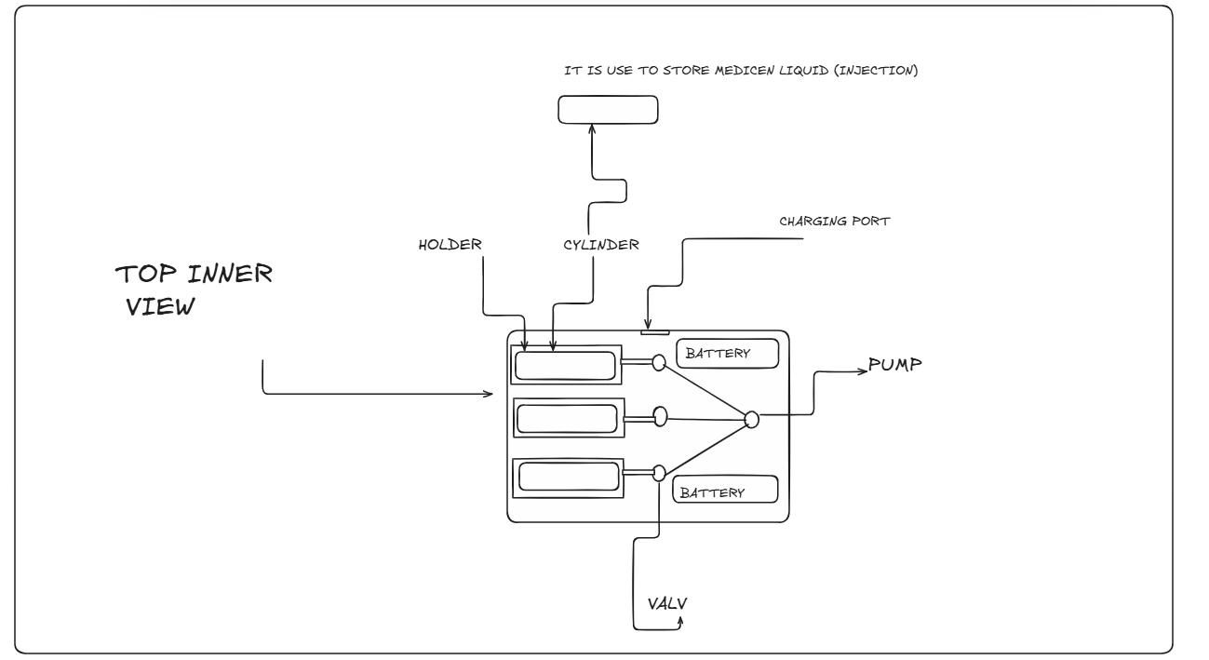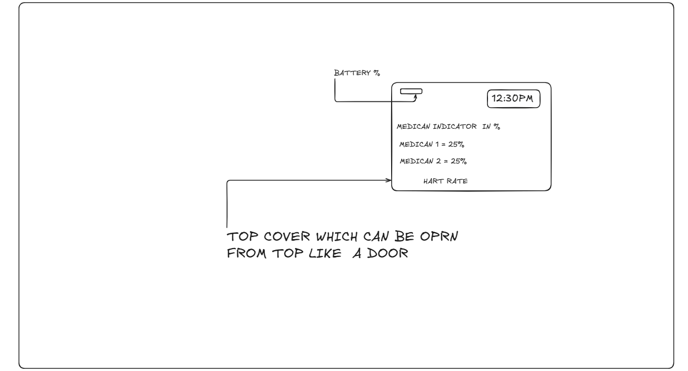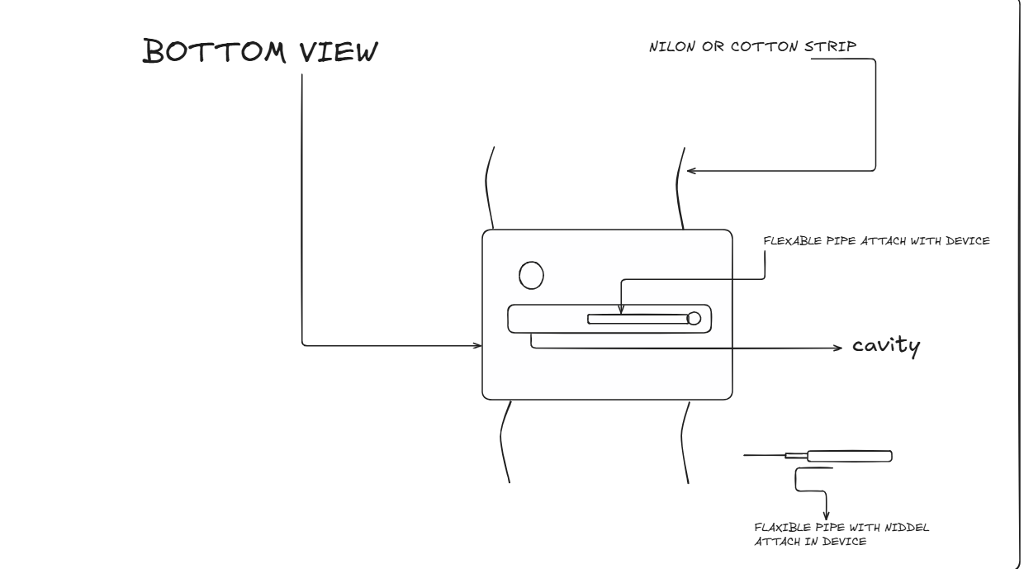

7. ABSTRACT (150 words)

This invention presents a wearable medical device in the form of a smartwatch that can store, mix, and inject liquid medicines based on a scheduled time or real-time emergency triggers such as irregular heart rate. The system includes multiple refillable medicine cylinders, a valve-mixing system, a micro-pump, and a flexible concealed injection pipe. It features a heart rate sensor that triggers automatic injection in the event of a suspected heart attack or critical cardiac event. The device’s display panel shows medicine levels, heart rate, and system status, while also allowing scheduling. This device helps cardiac, diabetic, or chronic condition patients receive accurate medication with zero delay, especially in life-threatening moments. It’s a unique fusion of smart wearables and emergency drug delivery.

8. BRIEFLY EXPLAIN THE STEPS, FLOW CHART, FUNCTIONALITY OF INVENTION RELATED TO SOFTWARE, EMBEDDING WITH MACHINE, DEVICE, APPRATUS.
***Note: Explain the functionality of software embedded with the device***

- Continuously read pulse data from heart rate sensor.
- Check for abnormal values using preset thresholds (e.g., <40 or >160 BPM).
- If emergency: override schedule → initiate injection (via pump + valve system).
- If not: check clock-based schedule → initiate timed injection.
- Show status on OLED or LCD display.
- Log data (optional future enhancement: sync with app).
- Low battery alerts, low medicine alerts, and vibrational feedback.

